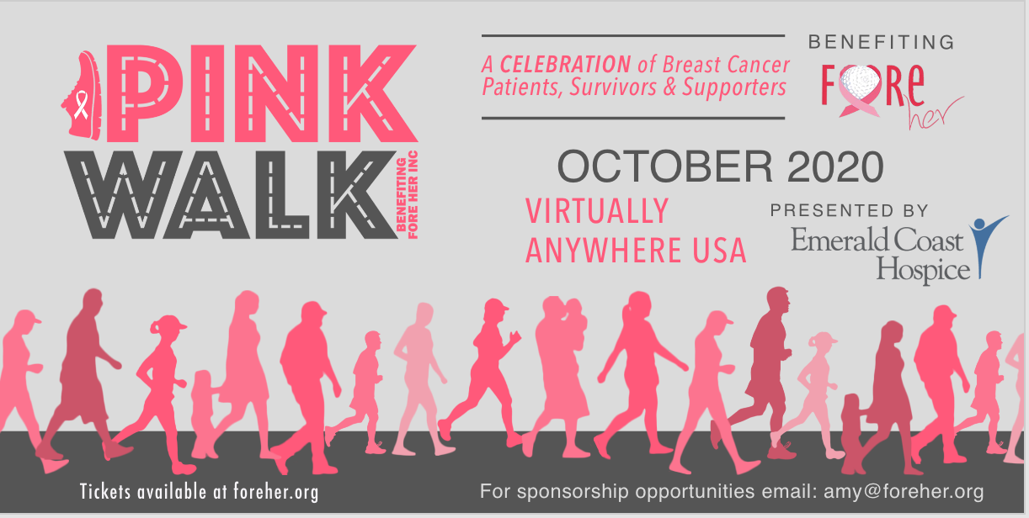

Starting October 15, 2020, Fore Her is set to host a Virtual Pink Walk to raise funds to support breast cancer patients financially struggling along the Florida panhandle. Now more than ever, we are receiving requests for assistance. We need your help so we can continue to serve the breast cancer community on the panhandle of Florida from Bay to Escambia county. All proceeds from this event will go toward the mission of Fore Her.

The funds raised allow Fore Her to help with expenses not covered by insurance. These expenses may include copays, medical bills, utilities, rent, car payments or repairs, mortgage payments among other bills that may come up while undergoing treatment. Fore Her works with recipients to understand how they can best provide some relief.

The Virtual Pink Walk will be held October 15 to November 15, 2020.

We would appreciate any support that you, your family and or business can provide, and we thank you for your consideration. There are many ways you can support in addition to participating in the walk.

If you have any questions, please contact Amy Walsh, Amy@ForeHer.org or Jennifer Crawford, Jennifer@ForeHer.org.

Thank you for your support!

For more information about Fore Her or the Pink Walk, visit ForeHer.org

Pink Walk Sponsorship Opportunities

Presenting Sponsor (SOLD)
- Company logo on event banner
- Listed as the Presenting Sponsor on Fore Her and Pink Walk 2020 websites, Logo with hyperlink on the sponsors page plus 75-Word company writeup and ad space on sponsor’s page
- Multiple mentions on the Pink Walk Facebook event page
- Prominent recognition on advertisements
- Mention in the pre-event press release*
- Facebook live interview during the event
- Eight complimentary walk entries
- Mention in pre and post-event e-blasts, and afterparty facebook live event.

Champion Distance Sponsor $1,000 - 1 Available
- Listed as Distance sponsor on Fore Her and Pink Walk website. First Place price will support Distance Sponsor’s business. Logo with hyperlink on the sponsors page plus 50-Word company writeup and ad space on sponsor’s page
- Multiple mentions on the Pink Walk Facebook event page
- Recognition on advertisements
- Facebook live interview during the event.
- 5 complimentary walk entries
- Mention in pre and post-event e-blasts, and afterparty facebook live event November 16, 2020 at 6 PM EST

Champion Top Fundraising Team Sponsor $1,000 - 1 Available
- Listed as Champion Team Fundraising sponsor on Fore Her and Pink Walk website. First Place price will support sponsor’s business. Logo with hyperlink on the sponsors page plus 50-Word company writeup and ad space on sponsor’s page
- Multiple mentions on the Pink Walk Facebook event page
- Recognition on advertisements
- Facebook live interview during the event.
- 5 complimentary walk entries
- Mention in pre and post-event e-blasts, and afterparty facebook live event November 16, 2020 at 6 PM EST

Champion Top Fundraising Individual Sponsor $1,000 - 1 Available
- Listed as Champion Team Fundraising sponsor on Fore Her and Pink Walk website. First Place prize will support Sponsor’s business. Logo with hyperlink on the sponsors page plus 50-Word company writeup and ad space on sponsor’s page
- Multiple mention on the Pink Walk Facebook event page
- Recognition on advertisements
- Facebook live interview during the event.
- 5 complimentary walk entries
- Mention in pre and post-event e-blasts, and afterparty facebook live event November 16, 2020 at 6 PM EST

25 mile – Water Bottle Sponsor $1,000 - 1 Available
- Company logo (one color) placed on Pink Walk water bottle given to participants who achieve at least 25 miles over the course of the event.
- Listed as Distance sponsor on Fore Her website. First Place price will support Distance sponsors business. Logo with hyperlink on the sponsors page plus 50-Word company writeup and ad space on sponsor’s page
- Mention on the Pink Walk Facebook event page
- Recognition on advertisements
- Facebook live interview during the event.
- 5 complimentary walk entries
- Mention in pre and post-event e-blasts, and afterparty facebook live event November 16, 2020 at 6 PM EST

Finisher Certificate Sponsor $500 - 1 Available
- Company logo (one color) placed on Pink Walk Finisher Certificate
- Listed as Finisher Certificate sponsor on Fore Her and Pink Walk 2020 website. Logo with hyperlink on the sponsor’s page
- Mention on the Pink Walk Facebook event page
- Recognition on advertisements
- Facebook live interview during the event.
- 2 complimentary walk entries
- Mention in pre and post-event e-blasts, and afterparty facebook live event November 16, 2020 at 6 PM EST

PATRON LEVELS

“Ultra Pink” Patron $500 plus a prize donation valued at a minimum of $500
- 5 complimentary walk entry
- Name listed on patron’s page

“Hot Pink” Patron $250 plus a prize donation valued at a minimum of $250
- 3 complimentary walk entry
- Name listed on patron’s page

“Lipstick Pink” Patron $125 plus a prize donation valued at a minimum of $100
- 2 complimentary walk entry
- Name listed on patron’s page

“Blush Pink” Patron $75 plus a prize donation valued at a minimum of $25.
- BOGO complimentary walk entry
- Name listed on patron’s page

SUPPORTER LEVELS

Family Supporter $500
- 4 complimentary walk entries
- Name listed on supporter’s page

Friend Supporter $100
- 1 complimentary walk entry
- Name listed on friend’s page

In Honor of or In Memory of Supporter $65
- Pink Walk 2020 Honor/Memory magnet

